**PHOTO SUMMARIZING (CAPTIONS, HASHTAGS) & PHOTO EDITING**

***TEAM:--***

|  |  |  |  |
| --- | --- | --- | --- |
| SUDA NAVEEN | KIRUTHIK SURIYAH M | RAJASREE | BHARGAVA RAMA REDDY |
| 20MIC0057 | 20MIS0321 | 20BEC0347 | 20MIC0047 |

***Abstract:--***

When you see an image, your brain immediately understands what it is about, but can a computer do the same? Computer vision researchers spent a lot of time working on this and thought it was unattainable until today. The goal of our project is to become familiar with the ideas of a CNN and LSTM model and to implement CNN with LSTM to create a working image caption generator model.We will develop the caption generator in this Python project using CNN (Convolutional Neural Networks) and LSTM (Long Short Term Memory). The picture features will be taken from the CNN model Xception, which was trained on the imagenet dataset, and fed into the LSTM model, which will provide the image captions.

1. **INTRODUCTION** 
   1. **Overview**

Our innovative web application combines advanced image analysis, caption generation, hashtag suggestions, and photo editing to give a full set of tools for image management and optimisation. Users can easily enhance their photographs and receive insightful information to improve their online presence by utilising advanced tools like YOLO for object detection, a sizable caption dataset, and OpenCV for photo editing.

1.2 **Purpose**

Our initiative fulfils a vital need by providing users with a simple and effective way to manage their photographs with captivating captions and greater discoverability. Users may save a lot of time and work by using our automated caption generation and trending hashtag ideas, which frees them up to concentrate on creating interesting content that connects with their target audience on well-known social media platforms.

Our solution offers a user-friendly approach by directly enhancing the user's image without overwhelming options. We focus on streamlining the editing process for a straightforward and hassle-free experience.

We want to enable users to create engaging visual content that captivates viewers, encourages engagement, and aids in the achievement of their online goals. To that end, we offer a user-friendly web tool that streamlines the image management process, creates captivating captions, and makes photo editing simple.

1. **LITERATURE SURVEY**

2.1 **Existing problem**

There are many existing approaches and methods for photo summarization, captioning, hashtag generation, and photo editing. However, these methods often have limitations in terms of accuracy, efficiency, and user-friendliness. Some of the specific problems that have been identified include:

* Captioning Accuracy: Existing captioning models often struggle to accurately describe the content of an image. They may produce captions that are semantically incorrect, lack relevant details, or exhibit flaws in natural language fluency.
* Hashtag Relevance: The generation of relevant and trending hashtags for images is a complex task. Existing methods may not effectively capture the context and content of the image, resulting in irrelevant or outdated hashtags that fail to maximize engagement and reach.

2.2 **Proposed solution**

* Improved Caption Generation: Our proposed approach harnesses advanced natural language processing algorithms and a scrupulous curated caption dataset. By combining these techniques, our aim is to generate captions for images that are highly accurate, contextually rich, and linguistically fluent. To ensure the delivery of top-quality options to the user, we utilize cutting-edge metrics such as Relevance, Accuracy, and Fluency to rank the captions.
* Context-Aware Hashtag Generation: Our proposed solution focuses on generating hashtags that precisely align with the image's context and content. By employing state-of-the-art techniques, we aim to generate 30 trending hashtags that maximize the image's discoverability and potential engagement on social media platforms.
* we prioritize a user-friendly approach by directly enhancing the user's image without overwhelming them with multiple options. Instead of providing a wide range of filters and editing choices, we focus on enhancing the image using advanced algorithms to improve its overall quality. By streamlining the editing process and removing complexity, we aim to provide a straightforward and hassle-free experience for users who want to enhance their images. Our goal is to offer a simple and intuitive interface that allows users to achieve the desired enhancements with ease.
* Through our proposed methods, we aim to surpass the limitations of existing approaches. Our solution emphasizes enhancing captioning accuracy and delivering relevant hashtags that optimize the impact of visual content. By incorporating advanced algorithms and techniques, we strive to provide an effective, efficient, and user-friendly solution for captioning, hashtag generation, and photo editing tasks.

1. **THEORITICAL ANALYSIS**

3.1 **Block diagram**

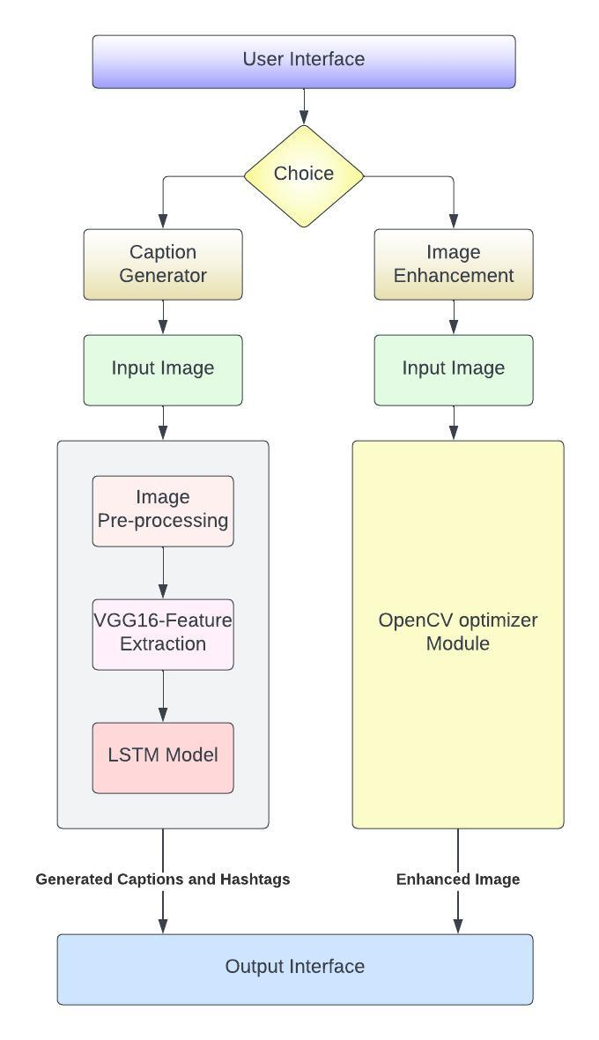

Img:1.Diagrammatic overview of the project.

3.2 **Hardware / Software**

**Hardware requirements:**

* Computer or Server: A computer or server with sufficient processing power and memory to handle image processing tasks efficiently.
* Storage: Adequate storage capacity to store the dataset, model files, and processed images.
* Internet Connectivity: A stable internet connection for accessing external resources, such as the caption dataset and trending hashtag information.

**Software requirements:**

* Operating System: Any modern operating system compatible with the selected software stack (e.g., Windows, macOS, Linux).
* Python: The programming language used for implementing the solution.
* Flask: A web framework for building the user interface and handling server-side logic.
* OpenCV: A computer vision library for image processing tasks, such as resizing, enhancing, and applying filters to images.
* YOLO (You Only Look Once): An object detection framework for detecting objects in images.
* Bootstrap: A popular front-end framework for creating responsive and user-friendly web interfaces.
* HTML/CSS: Markup and styling languages used for designing and formatting web pages.
* JavaScript: A programming language for adding interactivity and dynamic elements to the web application.
* By utilizing these hardware and software components, the project can be implemented effectively, providing a user-friendly website with image summarization, captioning, and photo editing capabilities.
* Edge:we are using edge as an web browser.

1. **EXPERIMENTAL INVESTIGATIONS**
2. **FLOWCHART**

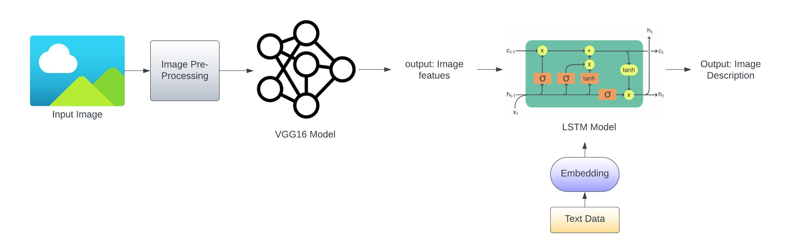

Img:2.1.flow of the model model how it trained, the background logic of the model.

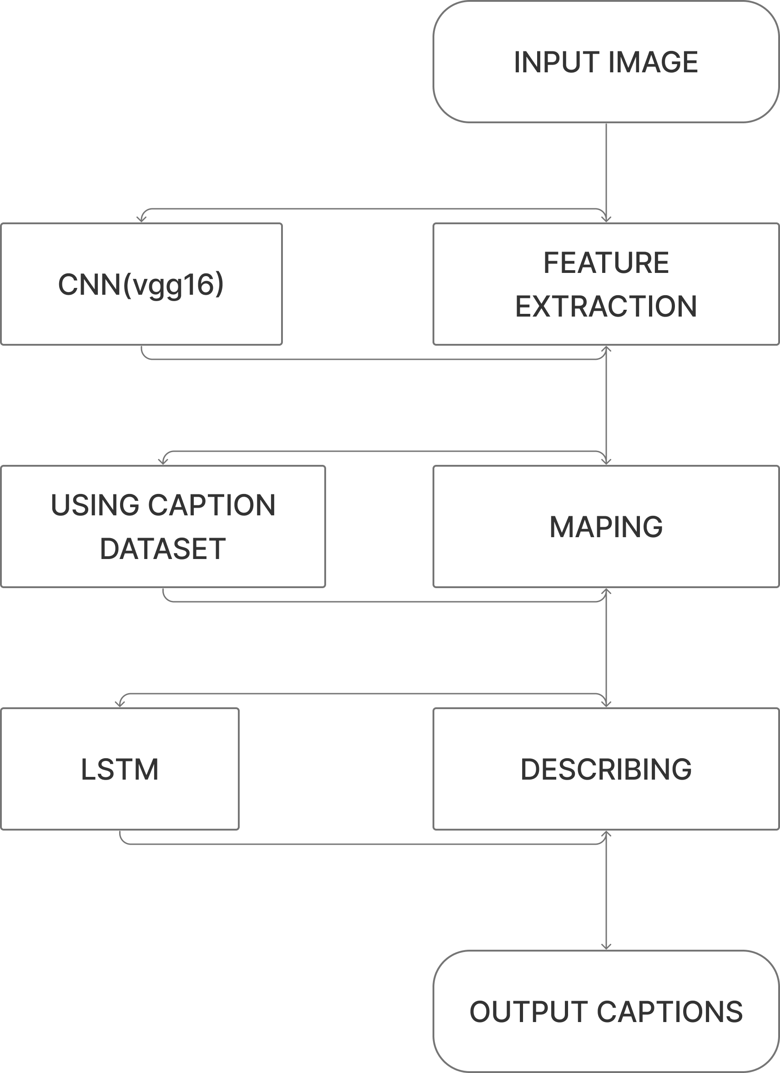

Img:2.2.Actual flow of the model, Flow chart of the model.

1. **RESULT**

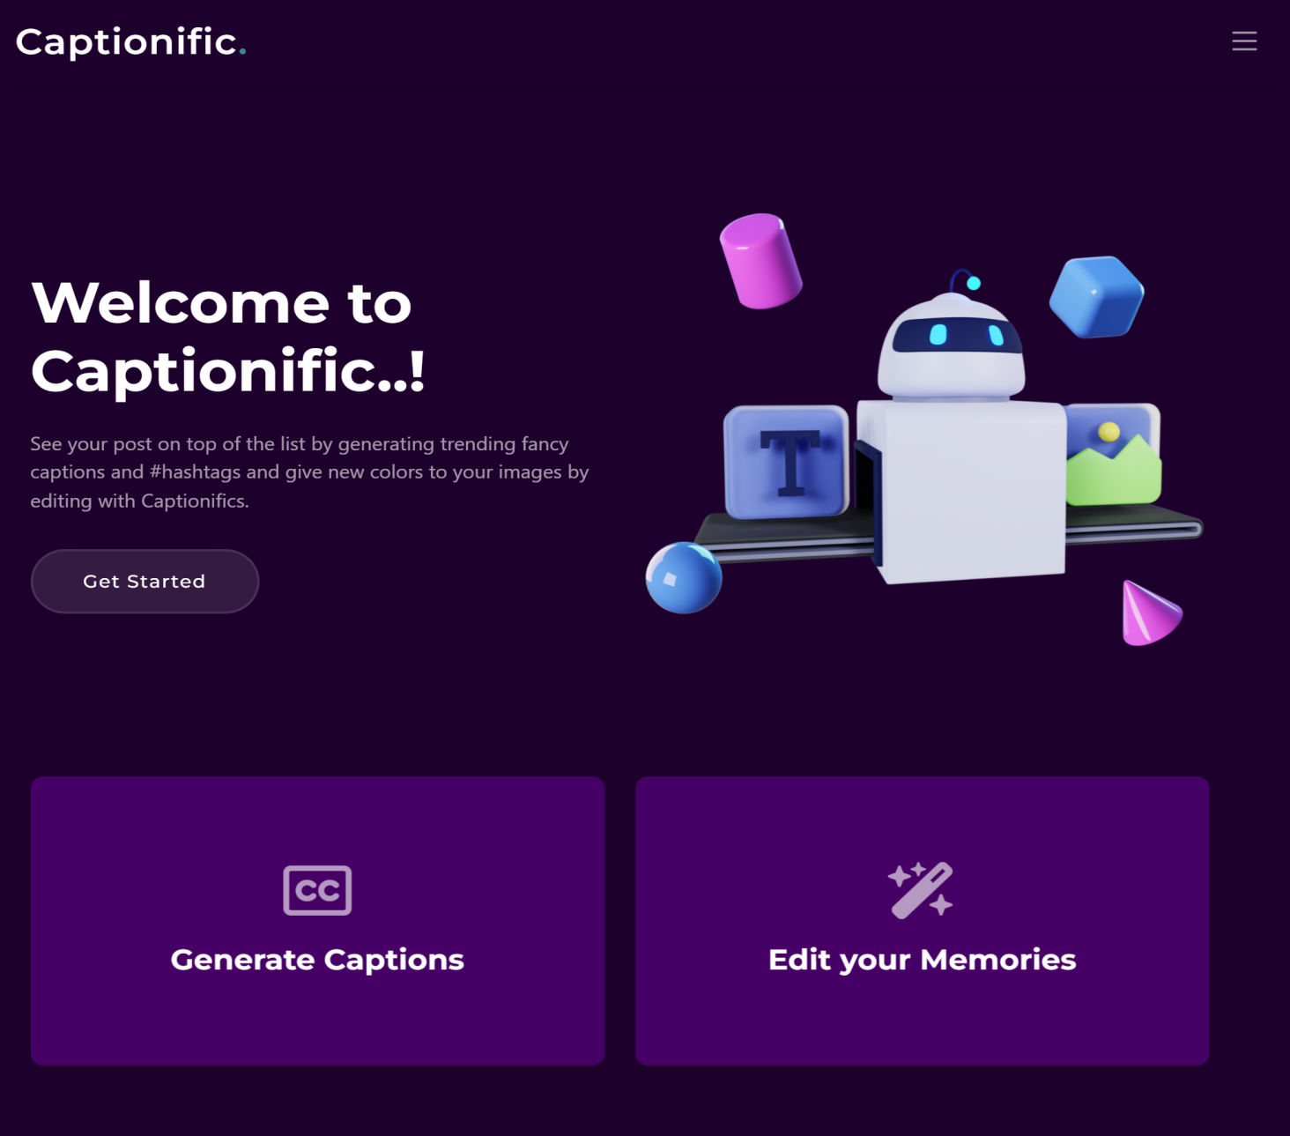

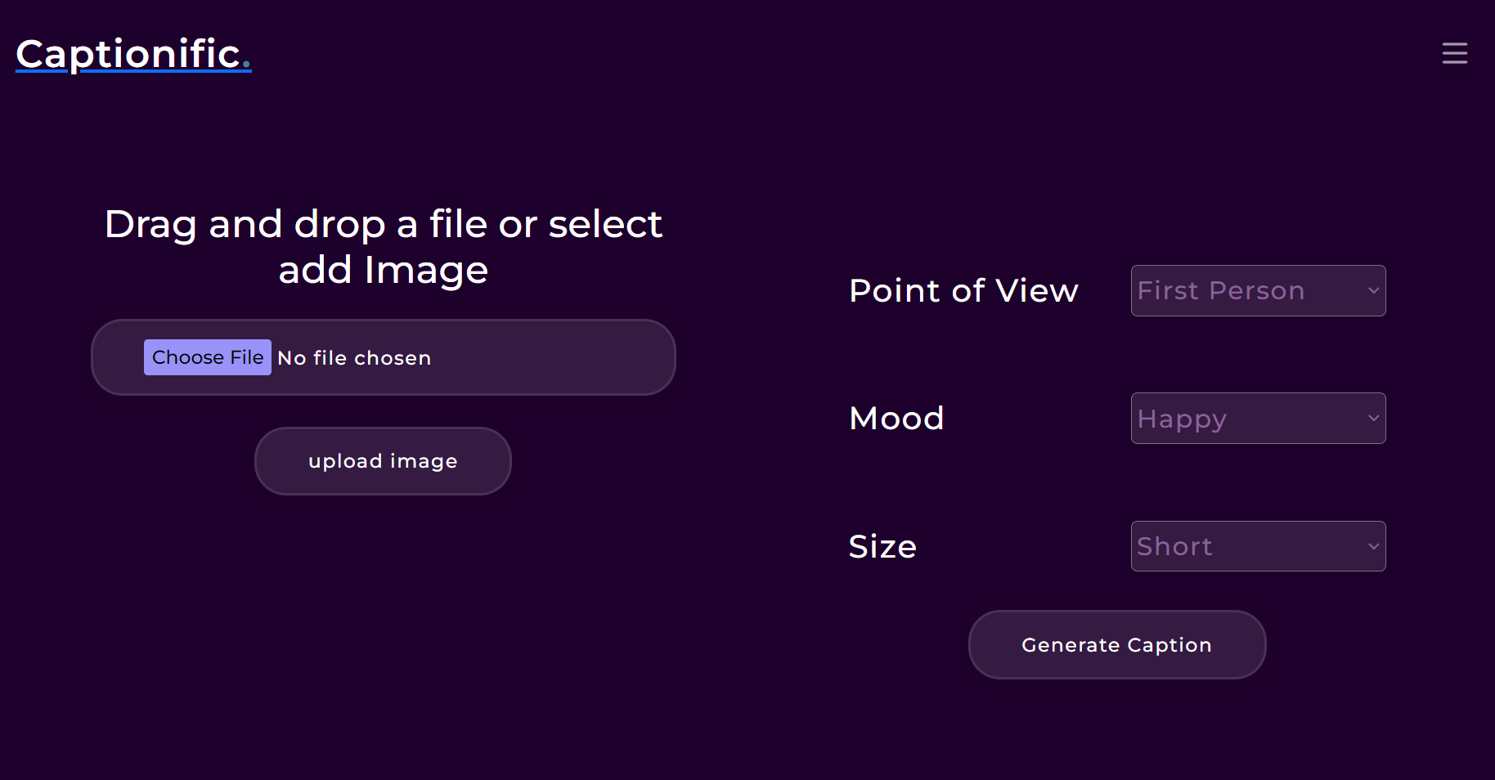

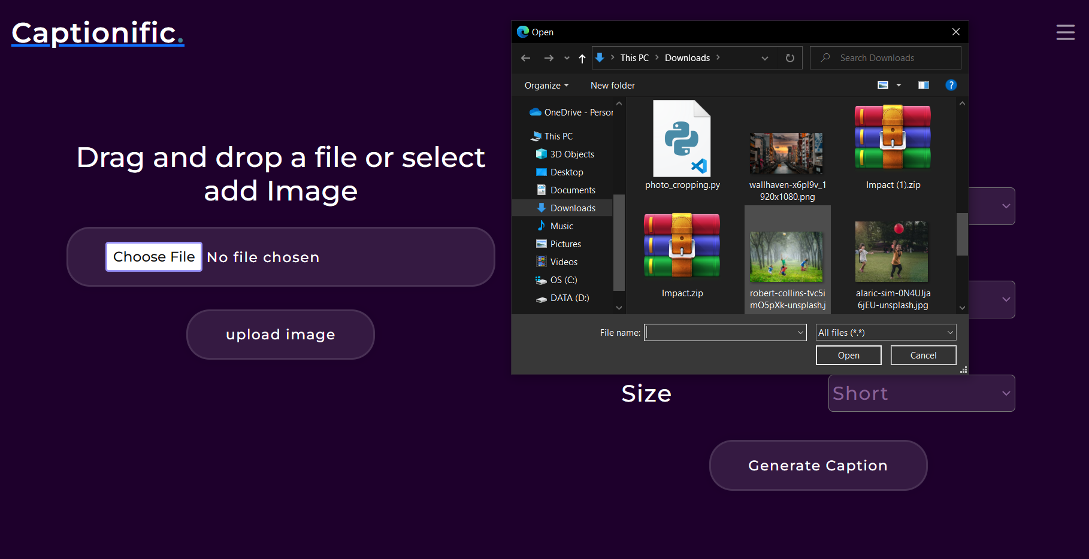

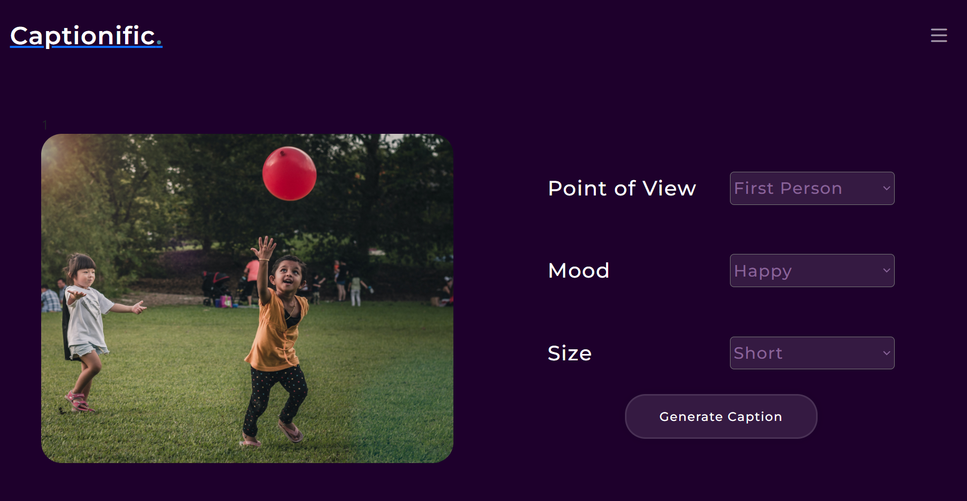

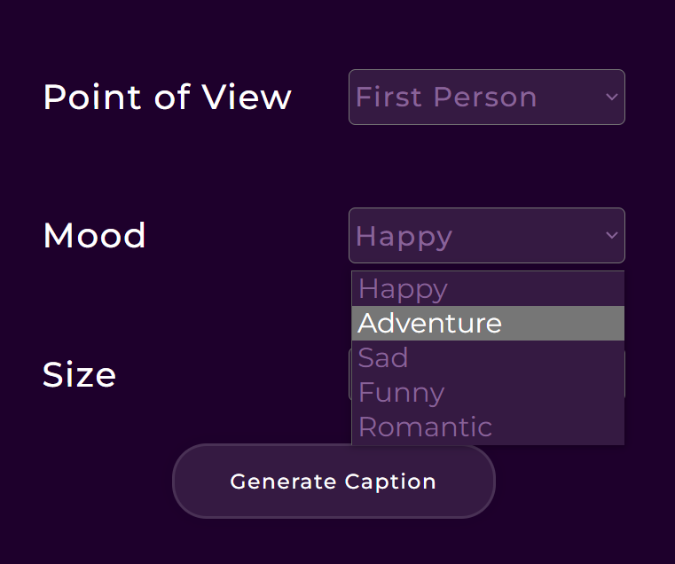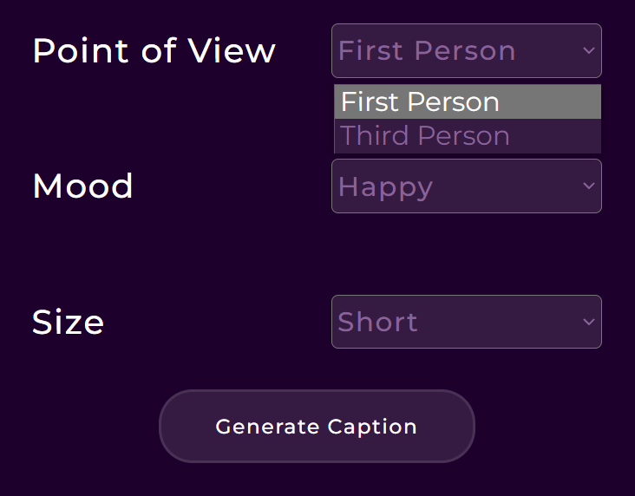

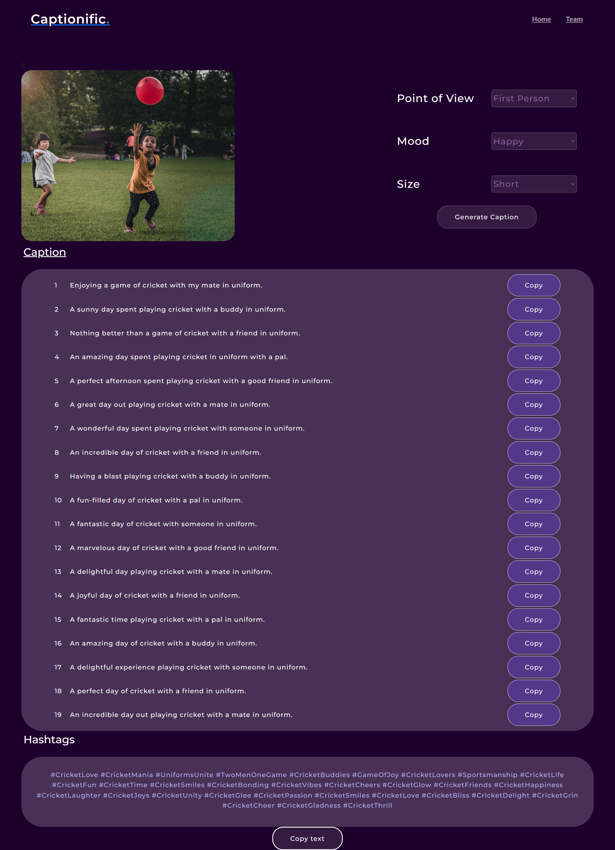

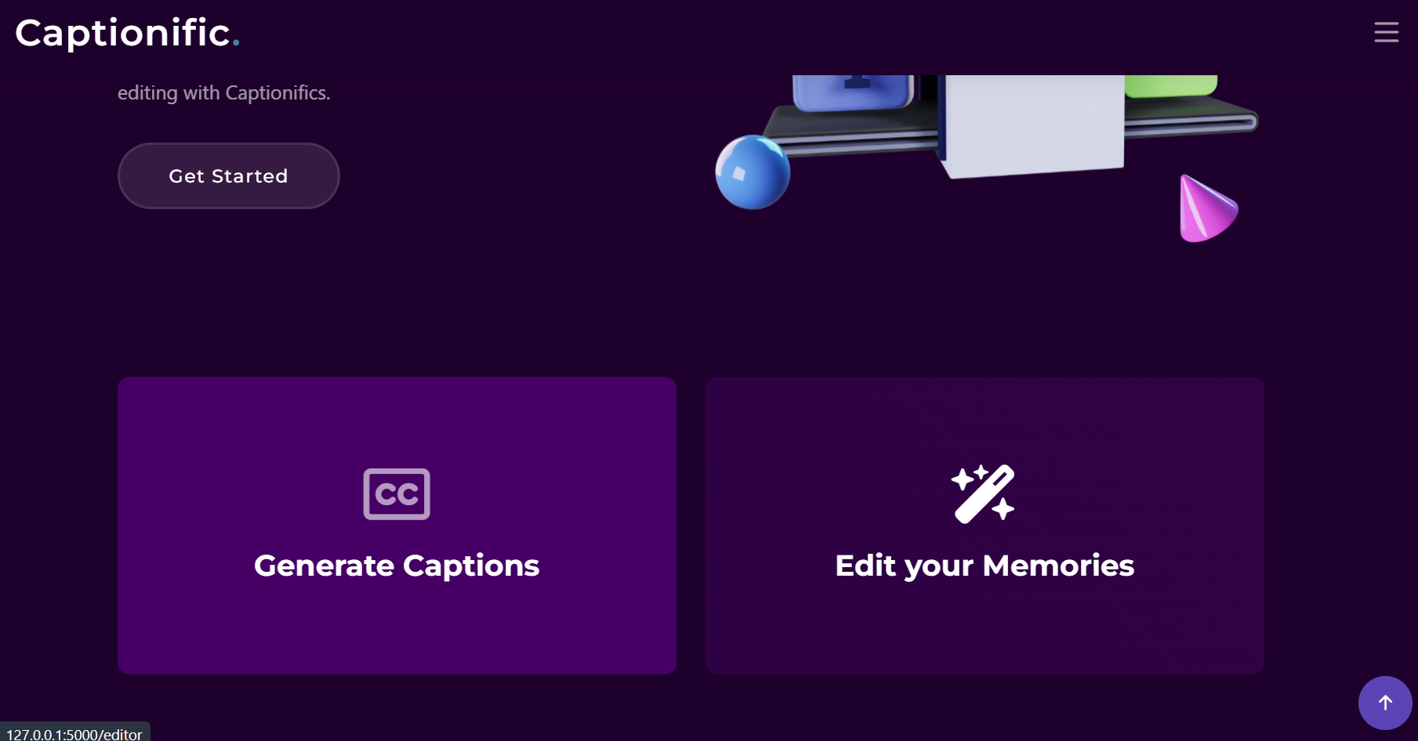

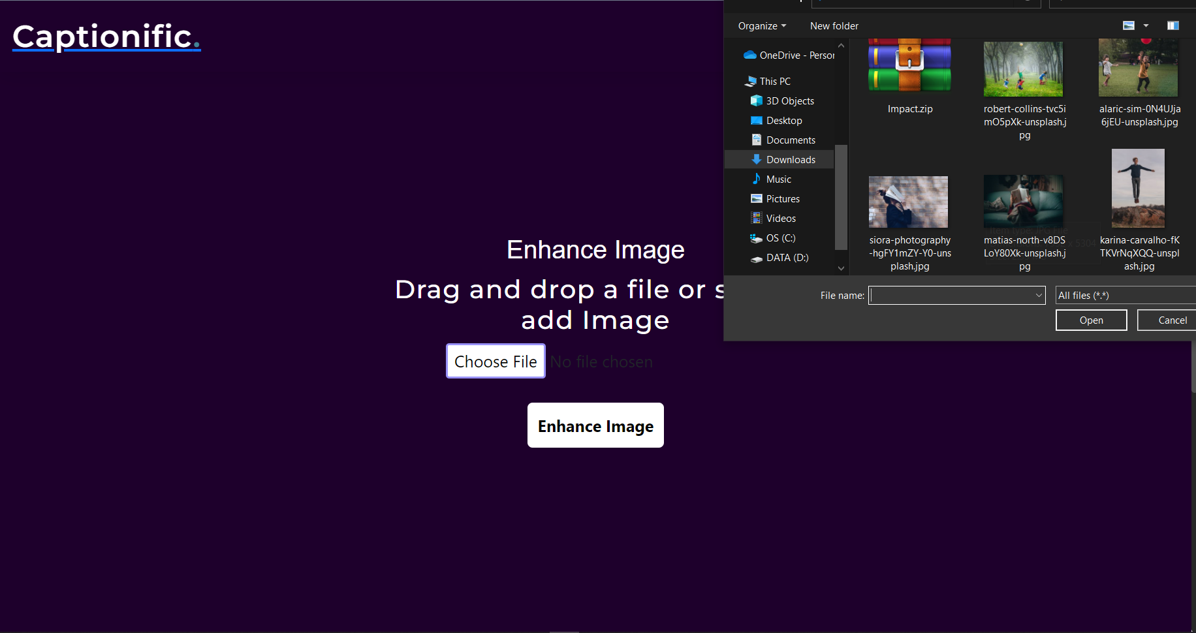

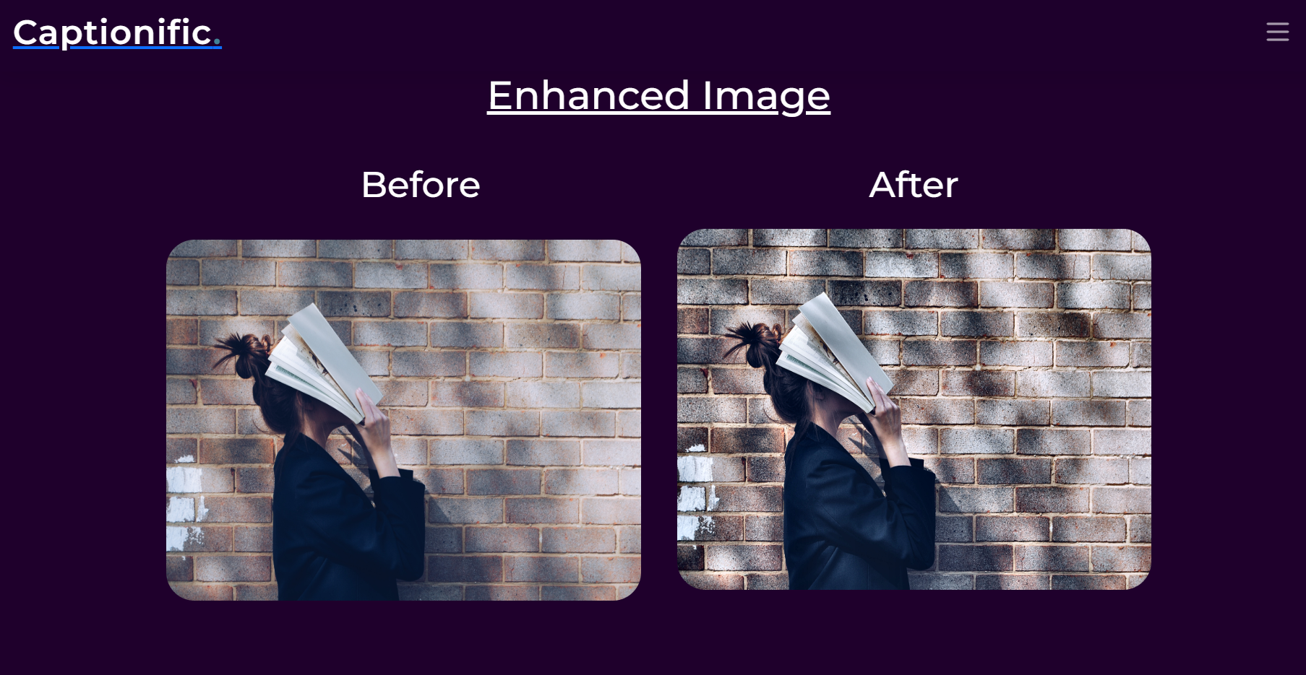

1. **ADVANTAGES & DISADVANTAGES**

**Advantages**

* **Saving time:** It can take some time to come up with interesting and inventive hashtags and captions. Websites that automatically generate relevant and well-liked captions and hashtags based on the content or theme of your post save time.

* **Engagement gain:** Well-written captions and well chosen hashtags can help increase engagement on social media sites. Utilising these tools will increase the likelihood of getting likes, comments, and shares by assisting you in creating captivating captions that connect with your audience.

* **Consistency and quality:** Online caption and hashtag generators make sure that your social media posts are both consistent and of high quality. You can select the most appropriate and excellent captions and hashtags that complement your brand or personal style from a variety of possibilities they offer.
* **Being aware of trends:** It can be difficult to keep up with the most recent trends and hashtags. Websites that generate captions and hashtags frequently incorporate popular hashtags and phrases, which can help you stay current and appeal to more people.

* **Audience targeting:** You can target particular audiences with the use of hashtags and effective captions. By using these tools, you can create hashtags that are well-liked in your sector or specialty, ensuring that the proper people see your material.

* **Benefits of SEO:** In social media search engine optimisation (SEO), hashtags are essential. Websites that create captions and hashtags assist you in creating hashtags that are search engine optimised, hence improving the discoverability of your postings.
* **Inspiration and creativity:** Websites that generate captions and hashtags serve as sources of ideas and encourage originality. They provide a range of caption and hashtag alternatives that can assist you in coming up with fresh concepts and original techniques for your social media material.

* **User-friendly design:** The majority of caption and hashtag generator websites have intuitive user interfaces that make it simple for anyone of any technical proficiency to produce captions and hashtags fast and effectively.

**Disadvantages**

* **Lack of originality:** Websites that create captions and hashtags offer pre-written text that could be boring or repetitive. Due to the widespread usage of these tools, there is a chance that your hashtags and captions will wind up sounding the same as or being the same as those of other users, which will make your material less distinctive and memorable.

* **Automated hashtag and caption** generators may provide generic and impersonal content that doesn't accurately represent your brand or individuality. To make the automatically generated captions and hashtags more engaging and real, it's crucial to customise them with your own style.
* **Limited customizability:** Typically, caption and hashtag generators provide a predetermined selection of alternatives based on themes or keywords. They might not offer you the level of customisation you want, though. These tools might not be perfect for you if you have needs or a distinctive style.

* **Overuse of trending hashtags:** While using trending hashtags frequently or irrelevantly can appear spammy or unauthentic, they can also enhance visibility and interaction. Without taking into account their actual relevance to your content, relying entirely on hashtag generators could result in overusing trending hashtags.
* **Limited comprehension of context:** Caption and hashtag generators use algorithms and established patterns to function, which may not completely comprehend the context or subtleties of your content. This may lead to hashtags and captions that are improper or mismatched, which could harm the message or image of your brand.

* **Dependency on outside tools:** Using hashtag and caption generating websites frequently can lead to dependency on outside tools. To give your social media presence a more personalised and distinctive feel, it's crucial to improve your own writing abilities and originality.
* **Lack of real-time trends:** Websites that generate captions and hashtags might not always be up to speed with the hottest trends and most popular subjects. Their ability to capitalise on current trends may be limited since they might not be able to record real-time occurrences or changes in the social media ecosystem.

1. **APPLICATIONS**

* **Social media marketing:** Companies and brands use these resources to strengthen their online presence. They can add visual appeal to images by editing and enhancing them, and they can utilise produced captions and hashtags to broaden their audience on social media sites like Instagram, Facebook, and Twitter.

* **Personal branding:** People with influence, bloggers, and content producers can use these methods to strengthen their online personas. In order to exhibit their individual style and draw in their target audience, they can edit their photographs to achieve a unified aesthetic and utilise pertinent captions and hashtags.
* **material creation**: With the use of photo editing software, users can improve the quality of their photographs and produce aesthetically appealing material for presentations, blogs, websites, and other online venues. Hashtags and captions are useful for communicating ideas, providing context, and boosting the visibility and discoverability of information.

* **E-commerce:** To improve product photographs and make them more appealing to potential customers, online vendors and e-commerce platforms utilise photo editing software. To describe products, emphasise benefits, and boost exposure to draw customers, utilise captions and hashtags.
* **Photography enthusiasts:** Both amateur and expert photographers can benefit from photo editing software to improve their images, change the lighting and colour, add filters, and produce beautiful visual effects. The photographs can be complemented by captions and hashtags, which might give more information or creative interpretation.

* **Personal expression and creativity:** These instruments can be used for these activities as well. Users can display their originality and creative vision on social networking sites by editing their own images, adding artistic aspects, and coming up with original captions and hashtags.

* **Travel and lifestyle blogging:** These tools are frequently used by travel and lifestyle bloggers to edit and improve their vacation images, write engrossing captions that describe their experiences, and use hashtags to reach a larger audience interested in their area of expertise.

1. **CONCLUSION**

In conclusion, websites that generate captions, hashtags, and photo captions have a wide range of benefits and uses for both individuals and organisations in the field of social media and online content development. These tools save time, enhance the visual appeal of photos, increase engagement, and improve the overall quality of content. They are especially useful for social media marketing, building personal brands, online shopping, producing content, promoting events, photography lovers, and travel and lifestyle bloggers.

While these tools are useful and inspiring, it's important to use them in a way that balances their use with individual originality and authenticity. They ought to be considered as jumping off points or inspiration, not as final answers. Making a distinctive and interesting online presence requires personalising generated captions and hashtags as well as being aware of context.

The secret is to properly use these tools to improve your content, express your uniqueness, and engage your target audience. You may improve your social media presence and produce engaging and aesthetically pleasing material by judiciously using photo editing, caption, and hashtag generating websites.

1. **FUTURE SCOPE**
2. **Enhanced customization options:** Platforms in the future might offer these features, giving consumers more control over the editing process. This might involve more sophisticated tools for fine-tuning particular aspects of an image, such as lighting, colours, and composition, as well as more imaginative filters and effects.
3. **Real-time collaboration:** Platforms for collaborative editing that let numerous users work on the same project at once could proliferate. Teams working on content production or marketing campaigns would particularly benefit from this because it would enable effective cooperation and quicker turnaround times.
4. **Integrated social media management:** photo editing, caption creation, and hashtag generating websites may connect increasingly closely with social media platforms as social media continues to develop. This could include real-time trend tracking, analytics, and direct publishing choices.
5. **Context-aware caption and hashtag generation:** Algorithms with a stronger grasp of context may be used in future improvements, enabling more precise and pertinent caption and hashtag suggestions. This could entail dissecting the image's visual composition, finding its essential components, and creating captions and hashtags that closely match it.
6. **Multilingual capabilities:** As global connectivity increases, tools for caption creation and photo editing may be able to accommodate multiple languages. Users with various linguistic backgrounds would be able to produce material in their native tongue in this way, increasing reach and engagement.
7. **Ethical and responsible editing:** Editing that is ethical and responsible: As technology develops, ethical issues in photo editing will receive more attention. Future platforms might have capabilities to identify and stop picture tampering or alteration that could cause harm or false information.
8. **BIBILOGRAPHY**

[1].Soh, M. (2016).Learning CNN-LSTM architectures for image caption generation.Dept.Comput. Sci., Stanford Univ., Stanford, CA, USA,Tech. Rep, 1.

[2].Amritkar, C., & Jabade, V. (2018, August). Image caption generation using deep learning technique. In 2018 fourth international conference on computing communication control and automation (ICCUBEA) (pp. 1-4). IEEE.

[3].Qu, S., Xi, Y., & Ding, S. (2017, May). Visual attention based on long-short term memory model for image caption generation. In 2017 29th Chinese control and decision conference (CCDC) (pp. 4789-4794). IEEE.

[4].Mulyanto, E., Setiawan, E. I., Yuniarno, E. M., & Purnomo, M. H. (2019, June). Automatic Indonesian Image Caption Generation using CNN-LSTM Model and FEEH-ID Dataset. In 2019 IEEE International Conference on Computational Intelligence and Virtual Environments for Measurement Systems and Applications (CIVEMSA) (pp. 1-5). IEEE.

[5].Hao Fang, Saurabh Gupta, Forrest N. Iandola, Rupesh Kumar Srivastava, Li Deng, Piotr Dollar, ´

[6].Jianfeng Gao, Xiaodong He, Margaret Mitchell, John C. Platt, C. Lawrence Zitnick, and Geoffrey Zweig. From captions to visual concepts and back. CoRR, abs/1411.4952, 2014.

[7].Ankit Kumar, Ozan Irsoy, Jonathan Su, James Bradbury, Robert English, Brian Pierce, Peter Ondruska, Ishaan Gulrajani, and Richard Socher. Ask me anything: Dynamic memory

[8].Ali Farhadi, Mohsen Hejrati, Mohammad Amin Sadeghi, Peter Young, Cyrus Rashtchian,Julia Hockenmaier, and David Forsyth. Every picture tells a story: Generating sentencesfrom images. In Proceedings of the 11th European Conference on Computer Vision: PartIV, ECCV’10, pages 15–29, Berlin, Heidelberg, 2010. Springer-Verlag.

[9].Kelvin Xu, Jimmy Ba, Ryan Kiros, Kyunghyun Cho, Aaron Courville, Ruslan Salakhutdinov,Richard Zemel, and Yoshua Bengio. Show, attend and tell: Neural image caption generationwith visual attention. arXiv preprint arXiv:1502.03044, 2015.

1. **Source Code**

app = Flask(__name__)

# Load

model_1 = VGG16()

model_1 = Model(inputs=model_1.inputs, outputs=model_1.layers[-2].output)

model = tf.keras.models.load_model('best_model.h5')

all_captions = []

with open(r'all_captions.txt', 'r') as fp:

for line in fp:

x = line[:-1]

all_captions.append(x)

def preprocess_image(image_path):

image = load_img(image_path, target_size=(224, 224))

image = img_to_array(image)

image = image.reshape((1, image.shape[0], image.shape[1], image.shape[2]))

image = preprocess_input(image)

return image

def idx_to_word(integer, tokenizer):

for word, index in tokenizer.word_index.items():

if index == integer:

return word

return None

def predict_caption(model, image, tokenizer, max_length):

in_text = 'startseq'

for i in range(max_length):

sequence = tokenizer.texts_to_sequences([in_text])[0]

# pad the sequence

sequence = pad_sequences([sequence], max_length)

# predict next word

yhat = model.predict([image, sequence], verbose=0)

# index with high probability

yhat = np.argmax(yhat)

word = idx_to_word(yhat, tokenizer)

if word is None:

break

in_text += " " + word

if word == 'endseq':

break

return in_text

def pre_fe(image):

temp = model_1.predict(image, verbose=0)

return temp

def enhance_image(image):

yuv_image = cv2.cvtColor(image, cv2.COLOR_BGR2YUV)

y, u, v = cv2.split(yuv_image)

clahe = cv2.createCLAHE(clipLimit=2.0, tileGridSize=(8, 8))

enhanced_y = clahe.apply(y)

enhanced_yuv = cv2.merge((enhanced_y, u, v))

enhanced_image = cv2.cvtColor(enhanced_yuv, cv2.COLOR_YUV2BGR)

blurred_image = cv2.GaussianBlur(enhanced_image, (0, 0), 3)

sharpened_image = cv2.addWeighted(enhanced_image, 1.5, blurred_image, -0.5, 0)

return sharpened_image

[CLICK HEAR FOR GITHUB REPOSITORIES AND TRAINING JUPYTER NOTEBOOK.](https://github.com/sudanaveen4/PHOTO-SUMMARIZING-CAPTIONS-genaration-HASHTAGS-PHOTO-EDITING-using-LSTM-CNN-OPENCV.)

****